2021 GGCC Final Championship Results
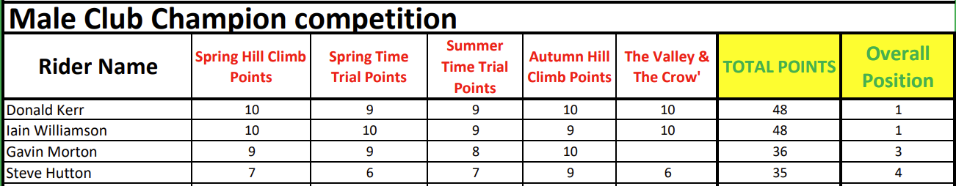
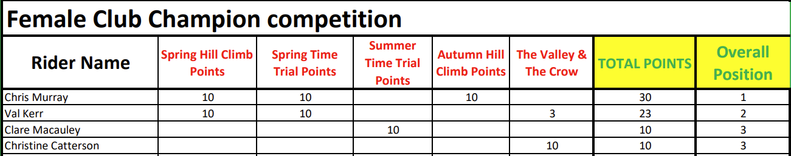
2021 GGCC Final Category Winners
